**DAILY ONLINE ACTIVITIES SUMMARY**

|  |  |  |  |  |  |  |  |  |
| --- | --- | --- | --- | --- | --- | --- | --- | --- |
| **Date:** | **09-06-2020** | | | | | **Name:** | **Preethi** | |
| **Sem & Sec** | **6th - B** | | | | | **USN:** | **4AL17CS065** | |
| **Online Test Summary** | | | | | | | | |
| **Subject** | | **CGV**  **CNSC** | | | | | | |
| **Max. Marks** | | **CGV - 30**  **CNSC - 60** | | **Score** | | | **GCV - 27**  **CNSC - 46** | |
| **Certification Course Summary** | | | | | | | | |
| **Course** | **Python for Data Science** | | | | | | | |
| **Certificate Provider** | | | **Cognitive Class-IBM**  **DeveloperSkillsNetwork** | | **Duration** | | | **7hours** |
| **Coding Challenges** | | | | | | | | |
| **Problem Statement: 2 Java and 2 Python program** | | | | | | | | |
| **Status: executed** | | | | | | | | |
| **Uploaded the report in GitHub** | | | | | **Yes** | | | |
| **If yes Repository name** | | | | | <https://github.com/PreethiNayak/Daily-Status/tree/master/09June2020> | | | |
| **Uploaded the report in slack** | | | | | **Yes** | | | |

Online Test Details: (Attach the snapshot and briefly write the report for the same)

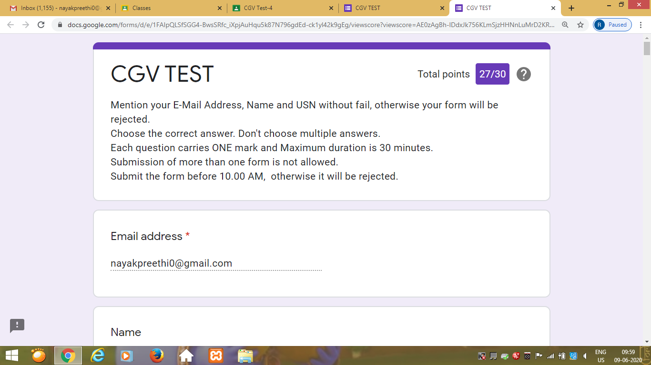

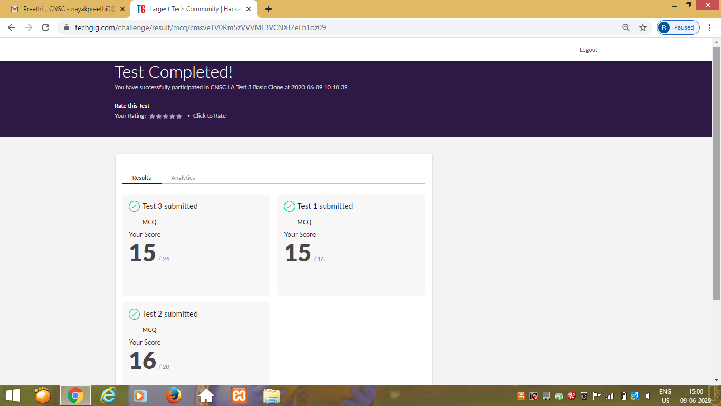

Certification Course Details: (Attach the snapshot and briefly write the report for the same)

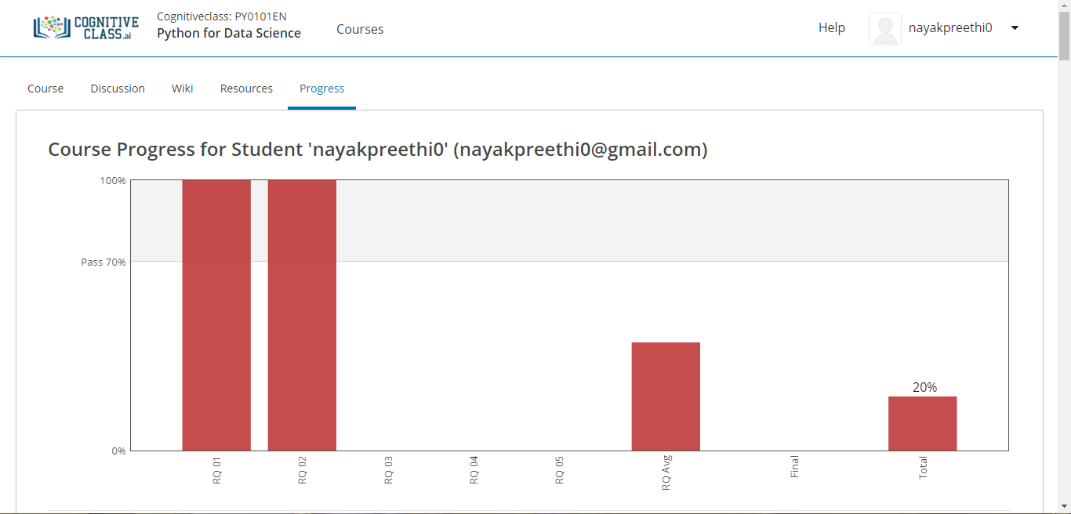

Today I completed module 2-“Python Data Structures”.

In that I studied about,

-List and Tuples.

-Sets and Dictionaries.

-attempted Quiz on this module.

Coding Challenges Details: (Attach the snapshot and briefly write the report for the same)

Program 1

This is output of python program to implement Perfect Sum Problem.

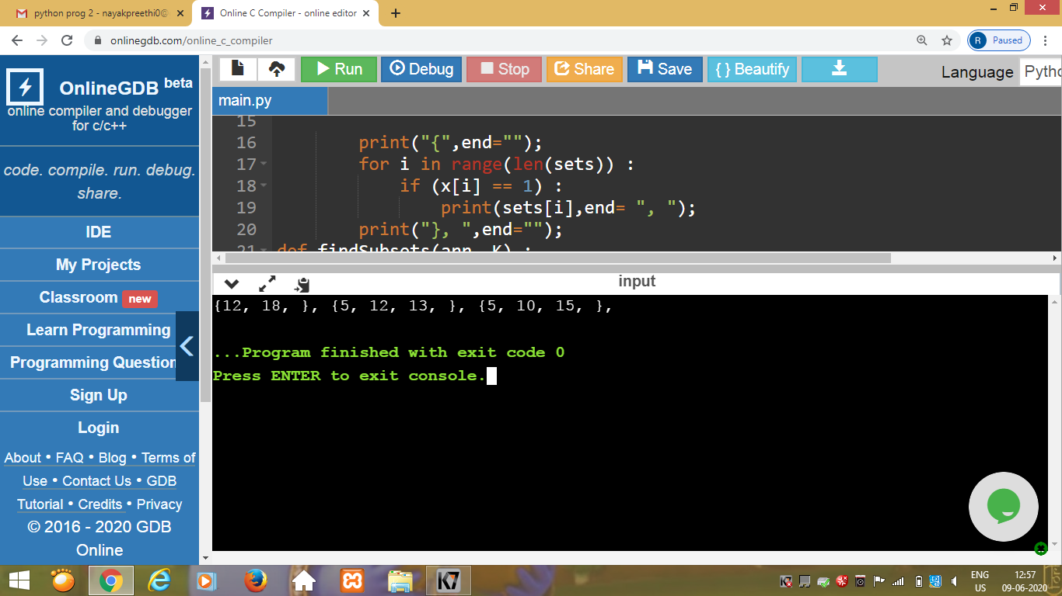

Program 2

This is the output of the java program to print smallest and biggest possible palindrome word in a given string.

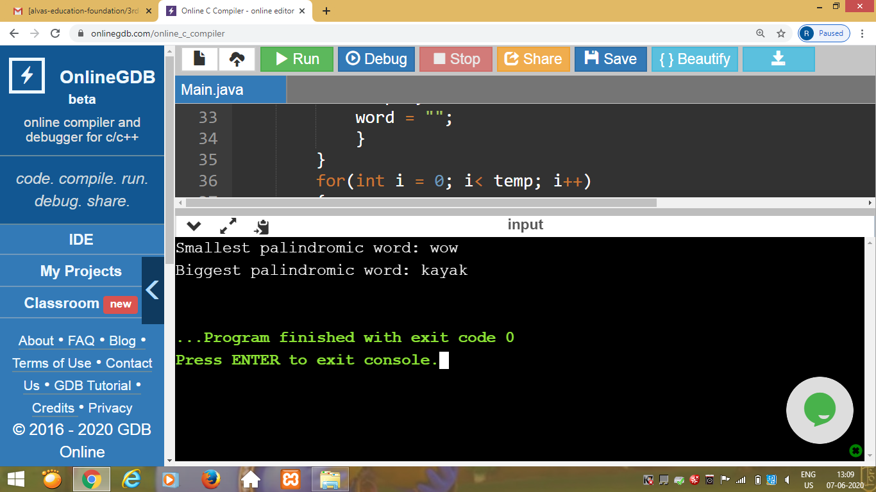

Program 3

This is the output of python program to  count the number of even and odd numbers from a series of numbers.

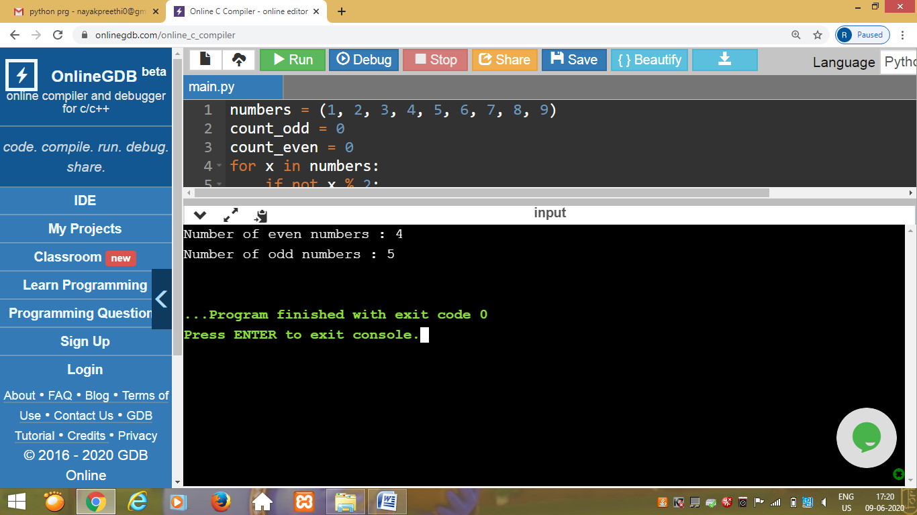

Program 4

This is the output of java program to remove all white spaces from a string without using replace().

